Search Template Instructions

1. Copy dollar amounts down the whole page worth (this screen is selecting three)

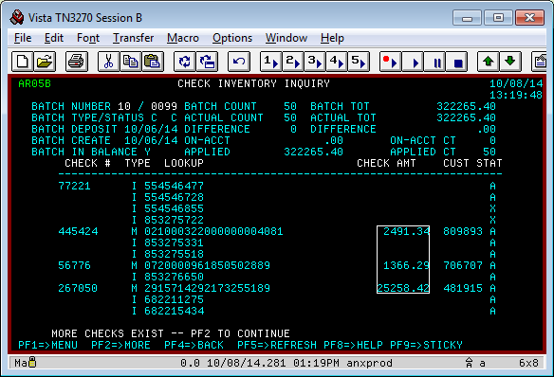

2. Paste onto column A:

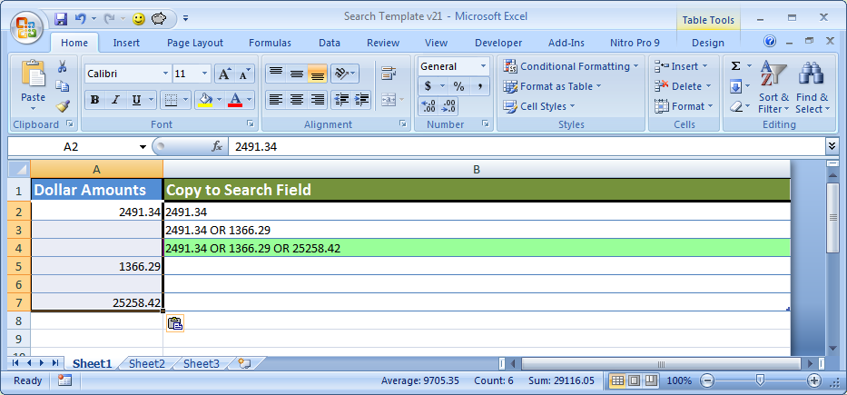

3. Once you're done pasting all your dollar amounts, you can copy the green cells in column B over to your search field to pull up to 10 back ups at a time (this is an example for batch (10-0238) :

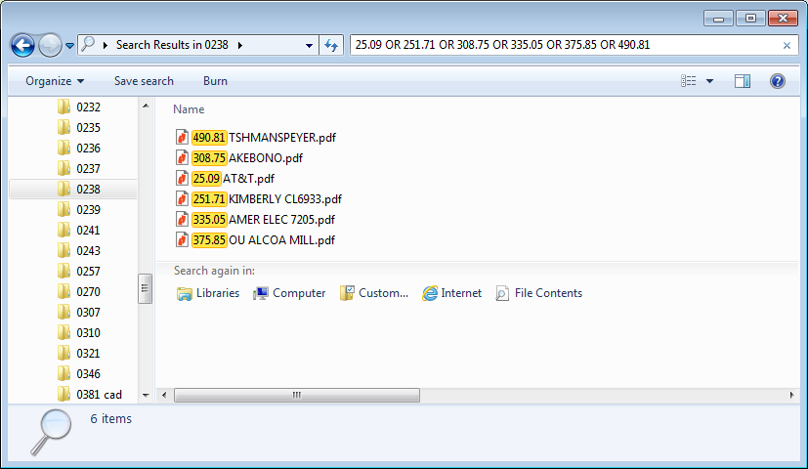

4. Select the first file, press Ctrl+A to select all, then cut and paste into your folder, or in this case, drag and drop to the folder on the left (you must have the batch folder as a network folder to do that):

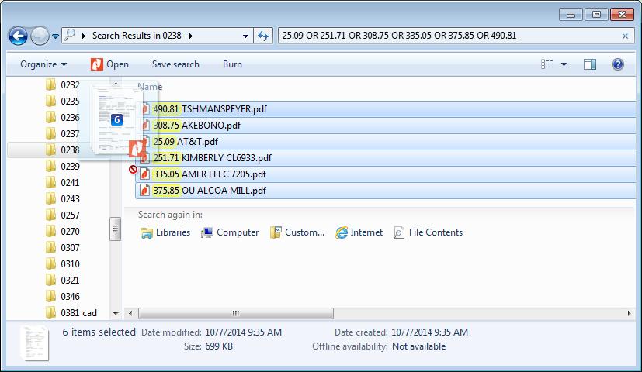

5. Copy the next green row from the search template, and repeat. Fast! :)

Possible Issues:

- When you copy paste, it pastes into other columns (oh noes!)
Fix:
- Type two numbers into column A:

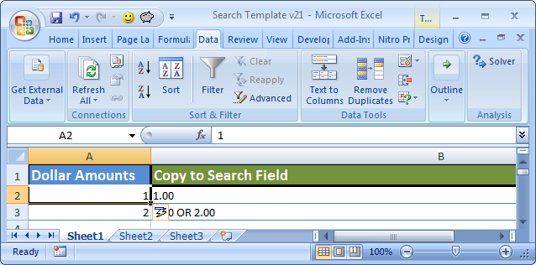

- Select the two numbers, go to Data Tab, click Text to Columns:
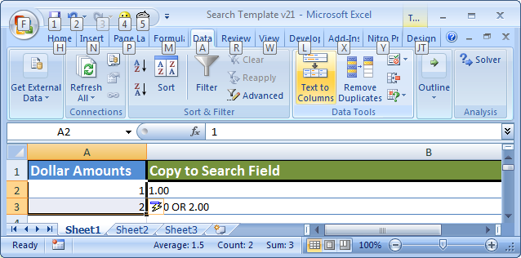

- Select the circle “Delimited”, click next, REMOVE ALL CHECK BOXES, then click Finish.
- Delete the two numbers you typed, and you are good to paste again! ☺

